**Group member Details:**

**Karan Patel – 16010421072**

**Keyur Patel – 16010421073**

**Batch : A3**

**Wp-II : Mini Project**

**Topic : Healthcare Management System**

**Github-link:** [github/mini-project/HealthCare-Management-System](https://github.com/keyur20/Healthcare-management/tree/master)

**Scope of Mini-Project:**

As technology advances nowadays, it is also important for the health care systems to automate all the processes which will help improve customer service and reduce the waiting time. Unlike the manual process, that essential information cannot be available in the necessary time as there are volumes of information that cannot be done if you do not have enough manpower.

In this ***Online Health Care System***,

* The user must register to have an account so; he can book an appointment and can get locations of the nearest hospitals with their respected names.
* The user also has the ability to see on the Home page different doctors assigned in the hospital along with their professions.
* They can also view the contact list of the admin, so the user can send a message directly to them if they have any questions, etc.

**Following are the features of the Online Health Care Management System:**

|  |  |  |  |
| --- | --- | --- | --- |
| **Admin Side** | **Doctor Side** | **Client Side** | **Public Side** |
| * **Manage Multi-Language** * **Display All Users** * **Manage Doctors** * **Manage Request** * **Manage appointments** * **Login and Logout** | * **Manage Profile** * **Manage Schedule** * **Manage Consulting Hour** * **Manage Appointments** * **View Notification** * **Manage Messages** | * **Manage Profile** * **Suggest Doctors** * **Manage Appointments** * **Manage Consultation** * **Notification** * **Login and Logout** | * **Manage Multi-Language** * **Home Page** * **View Doctors** * **Suggest Doctors** * **Blogs** * **Contact Us** * **Notification** |

**Public Side:**



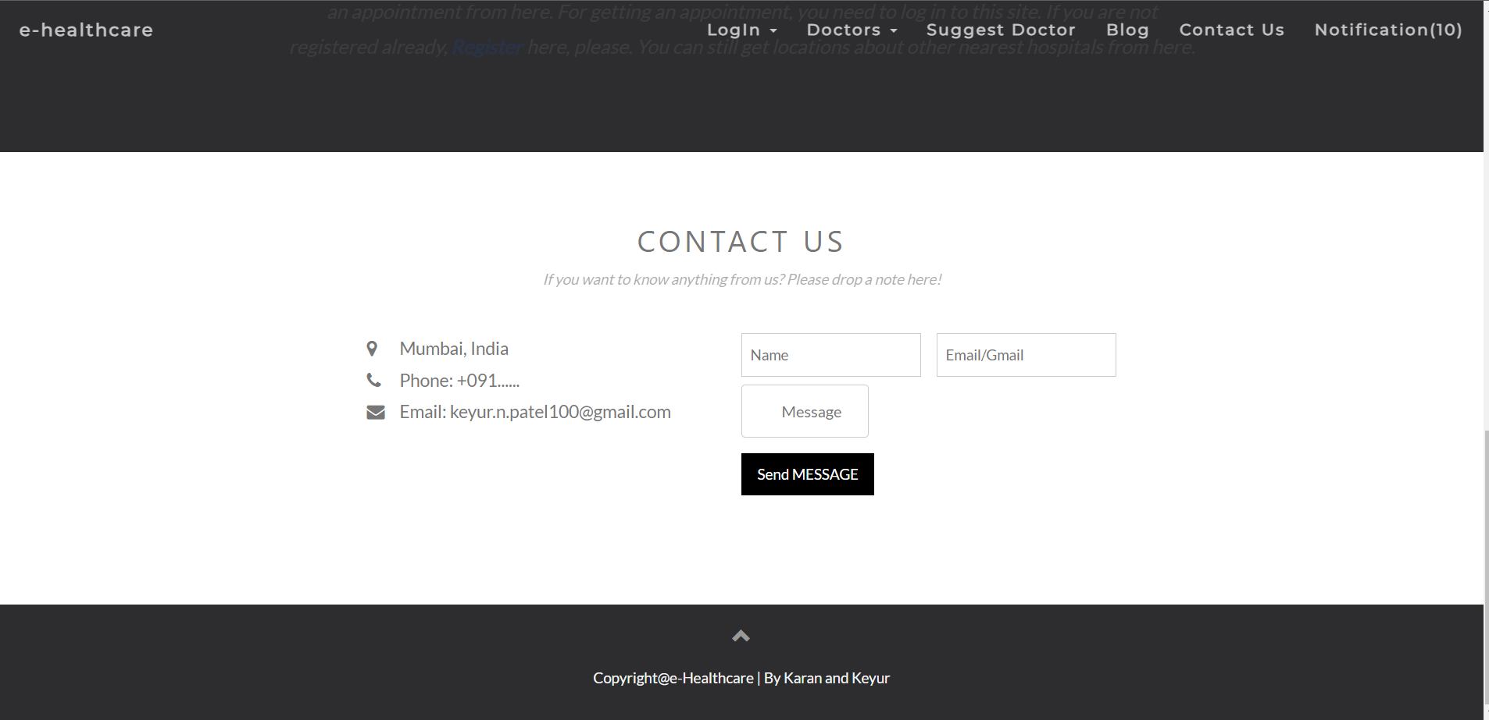

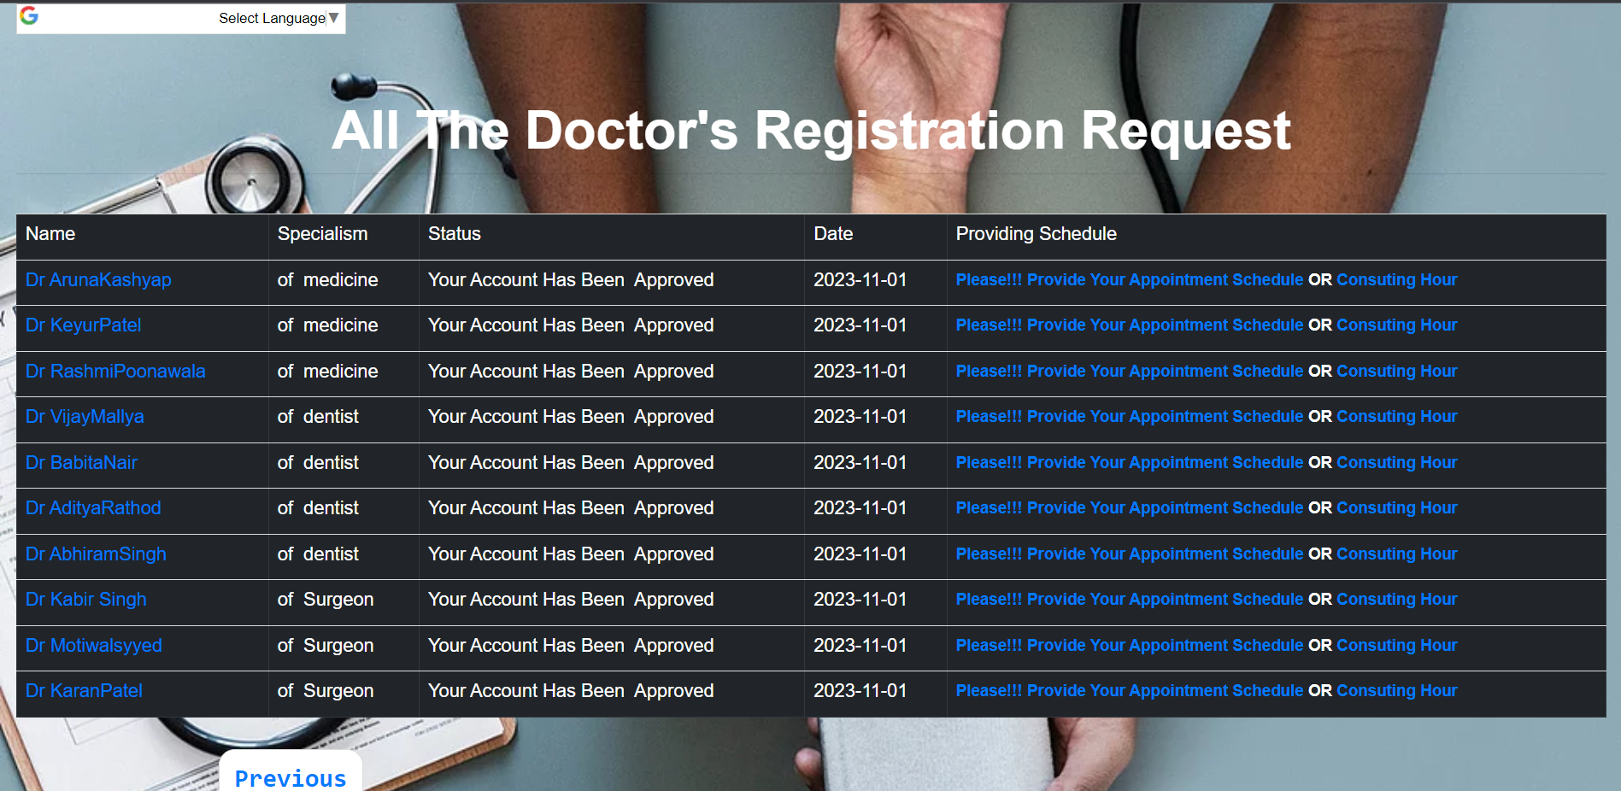

**Blog:**





**Public -> Suggest Doctor**

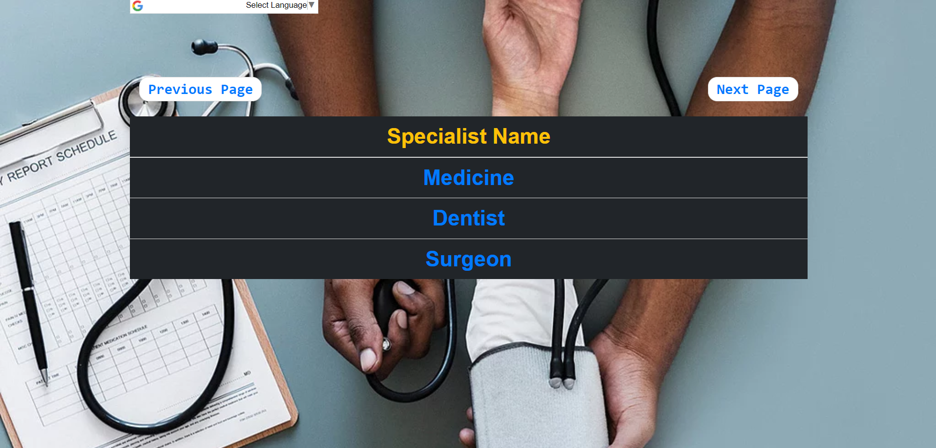

**Public -> Suggest Doctor -> Medicine**

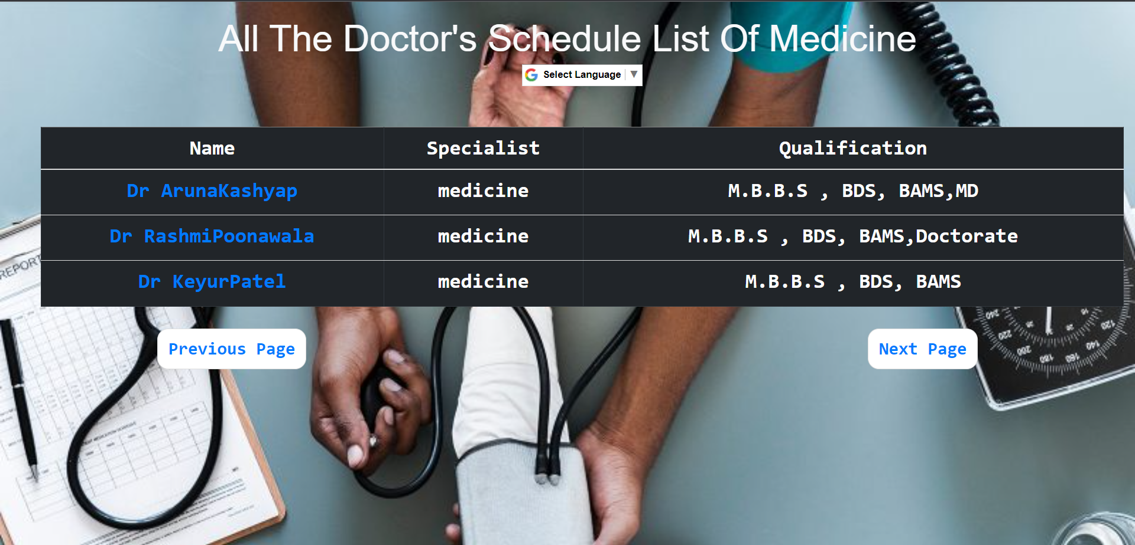

**Doctor Side:**

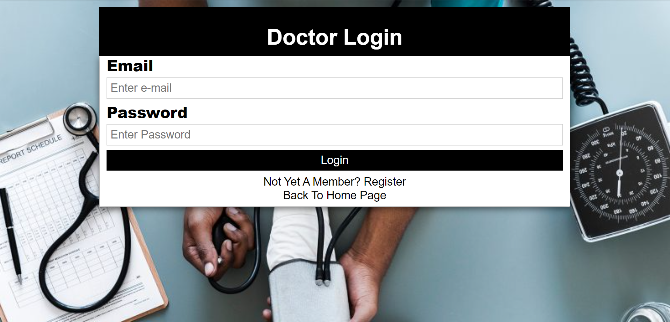

**Doctor -> Dashboard**

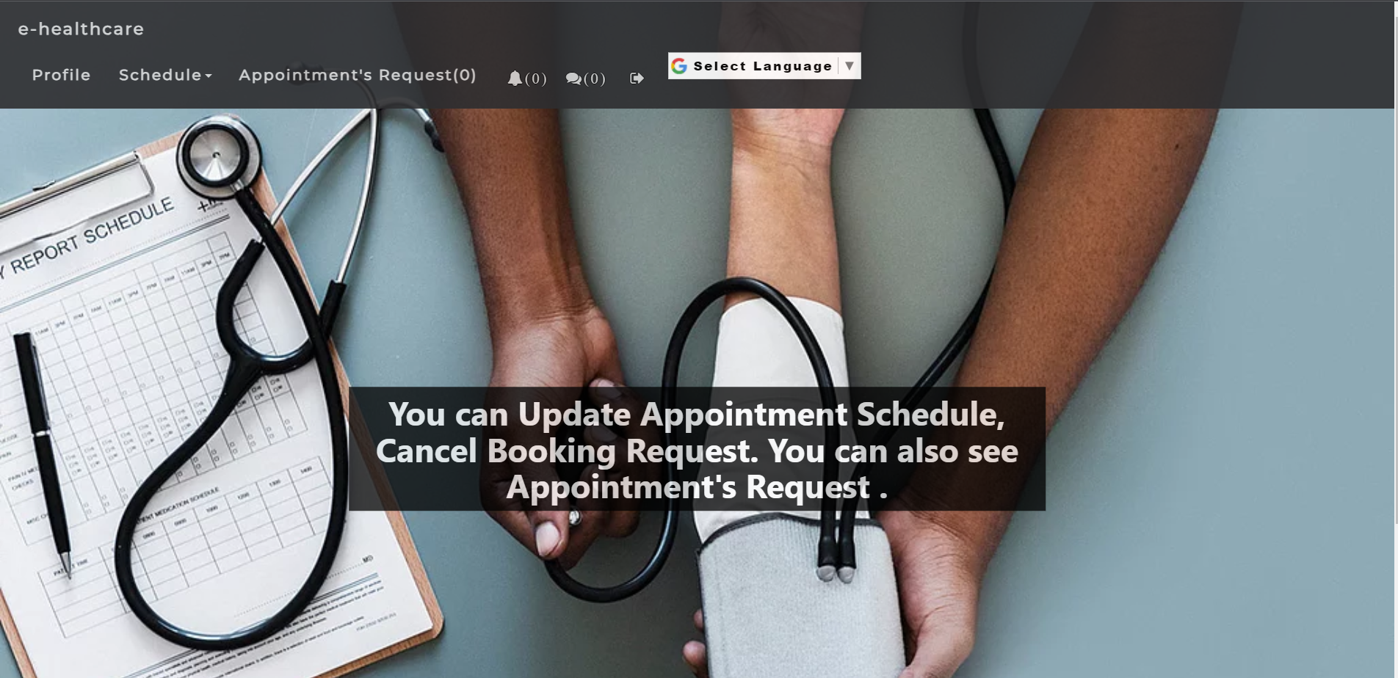

**Doctor -> Dashboard -> Personal-profile**

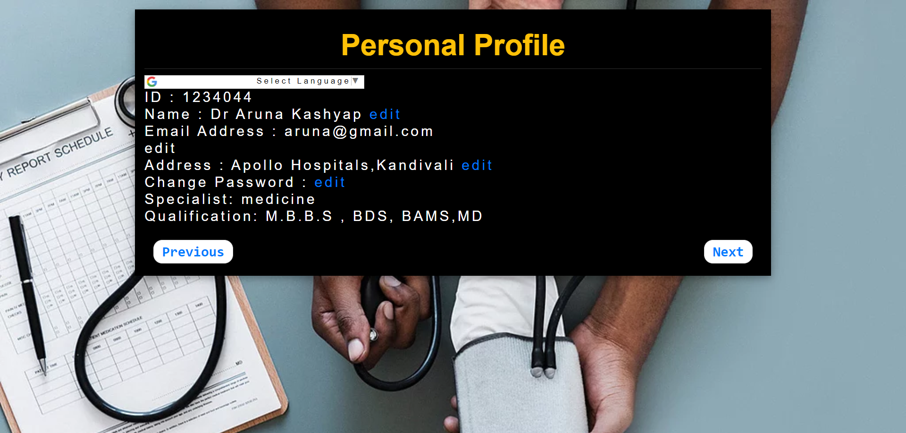

**Doctor -> Dashboard -> Consulting hour**

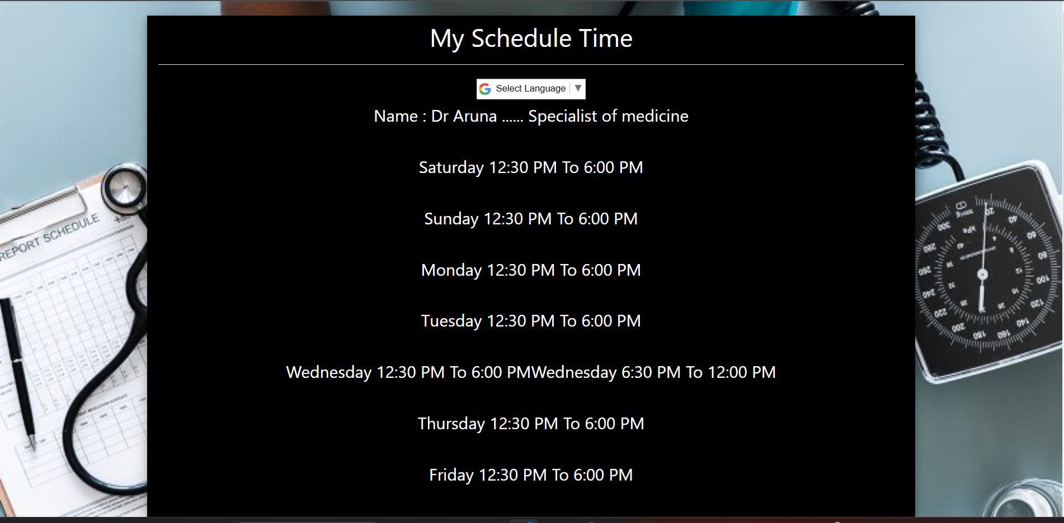

**Doctor -> Dashboard -> Appointment Request**

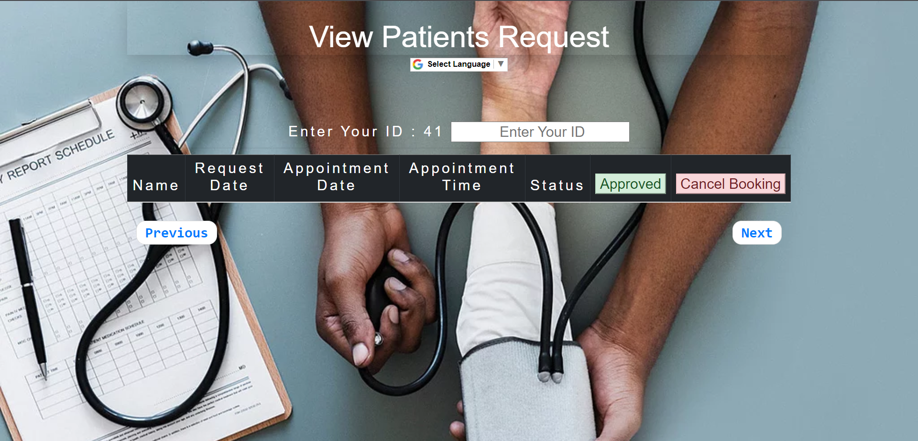

**Client Side:**

**Client-Login:**

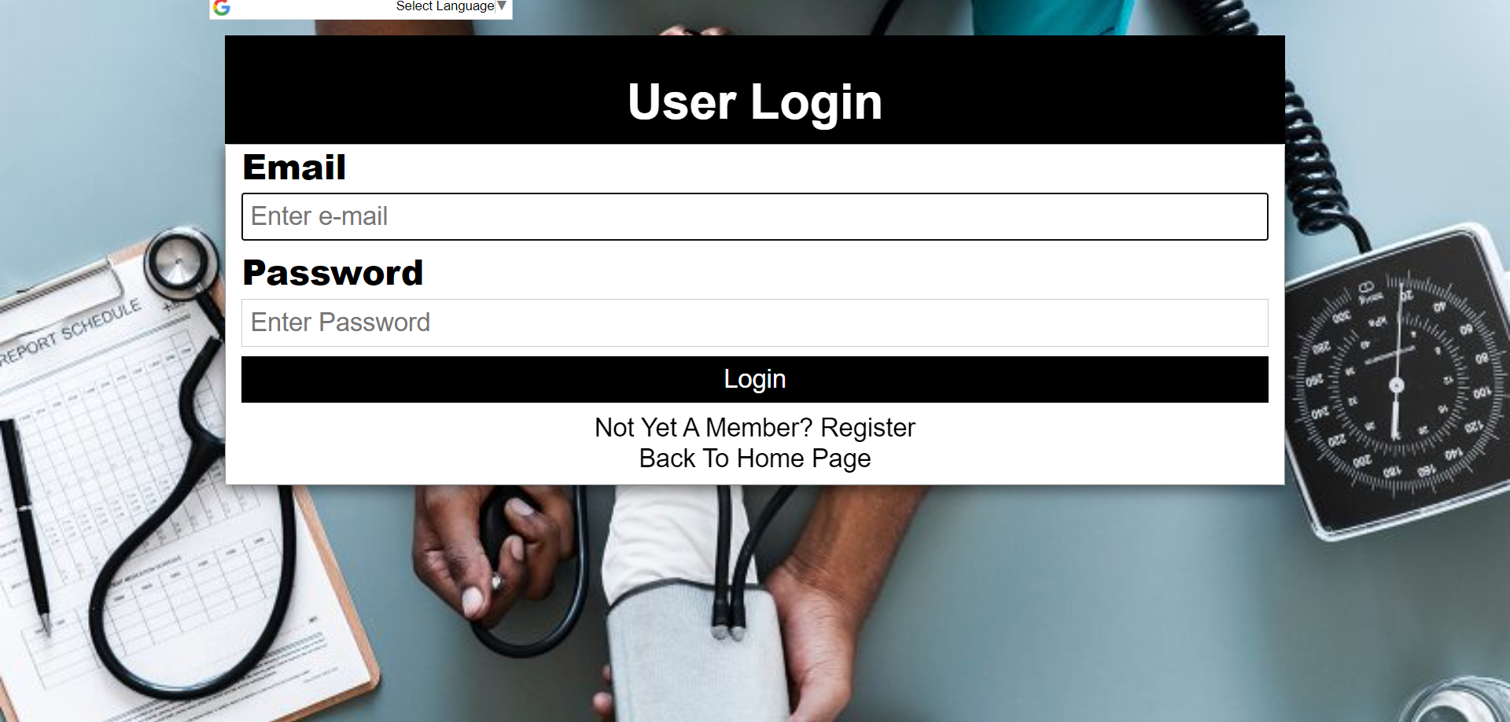

**Client-Dashboard:**



**Admin-Side:**

**Admin Login:**

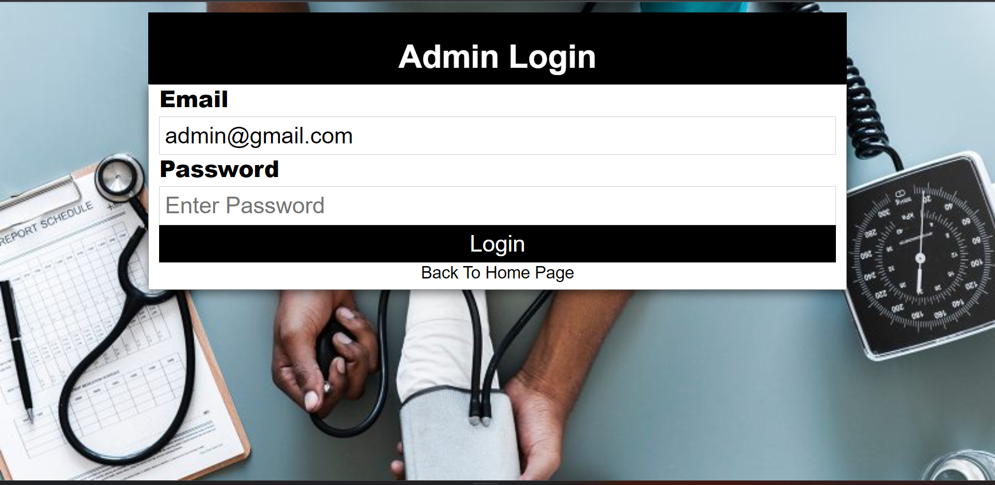

**Admin-Side -> Admin Dashboard(Doctors,Request,List of Appointments,Display user list)**



**Admin-Side -> Doctor registration Approval:**

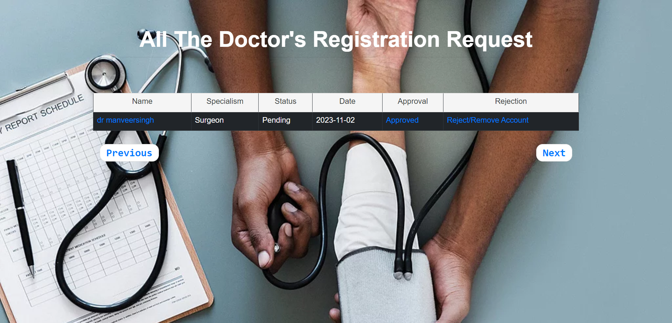

**Admin-Side -> Display User List:**

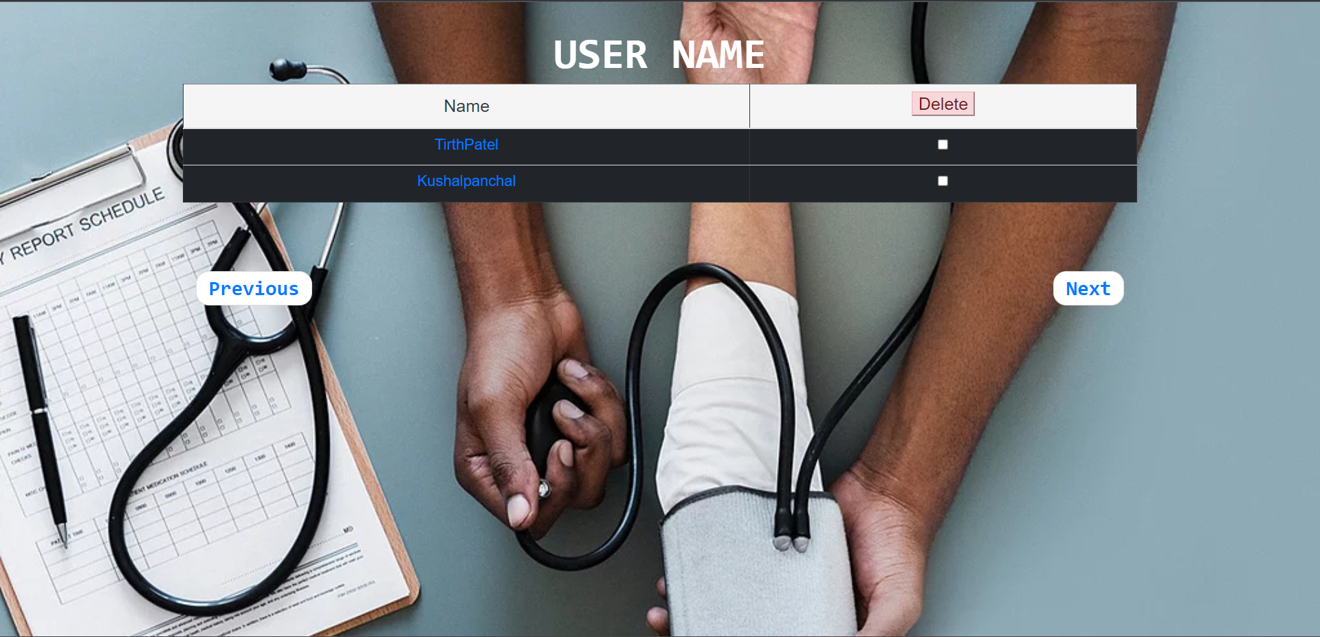

**Admin-Side -> List of All Appointments:**

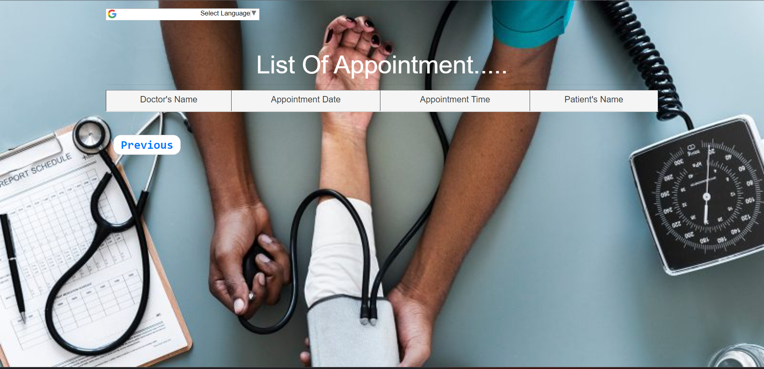

**Admin-Side -> Add Doctors Through Registration:**

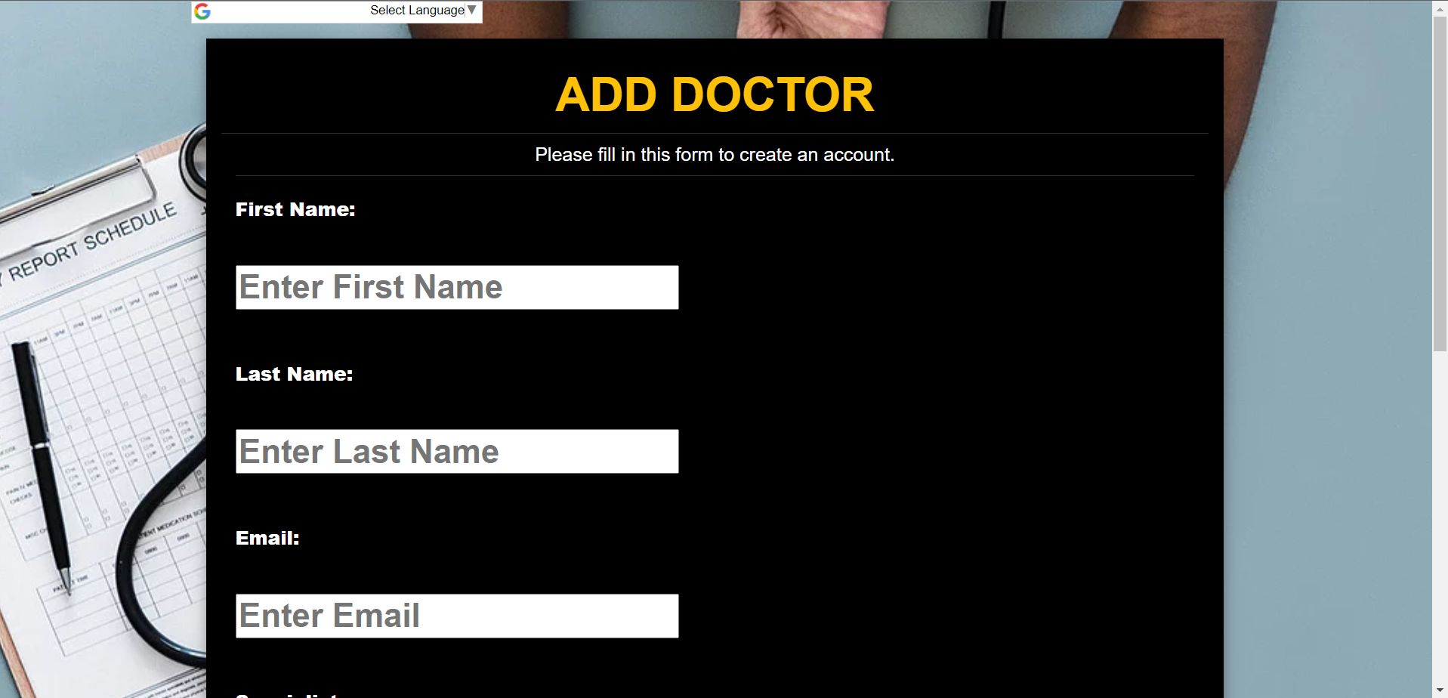

**Phpmyadmin**

**Database name : “healthcaredb”**

